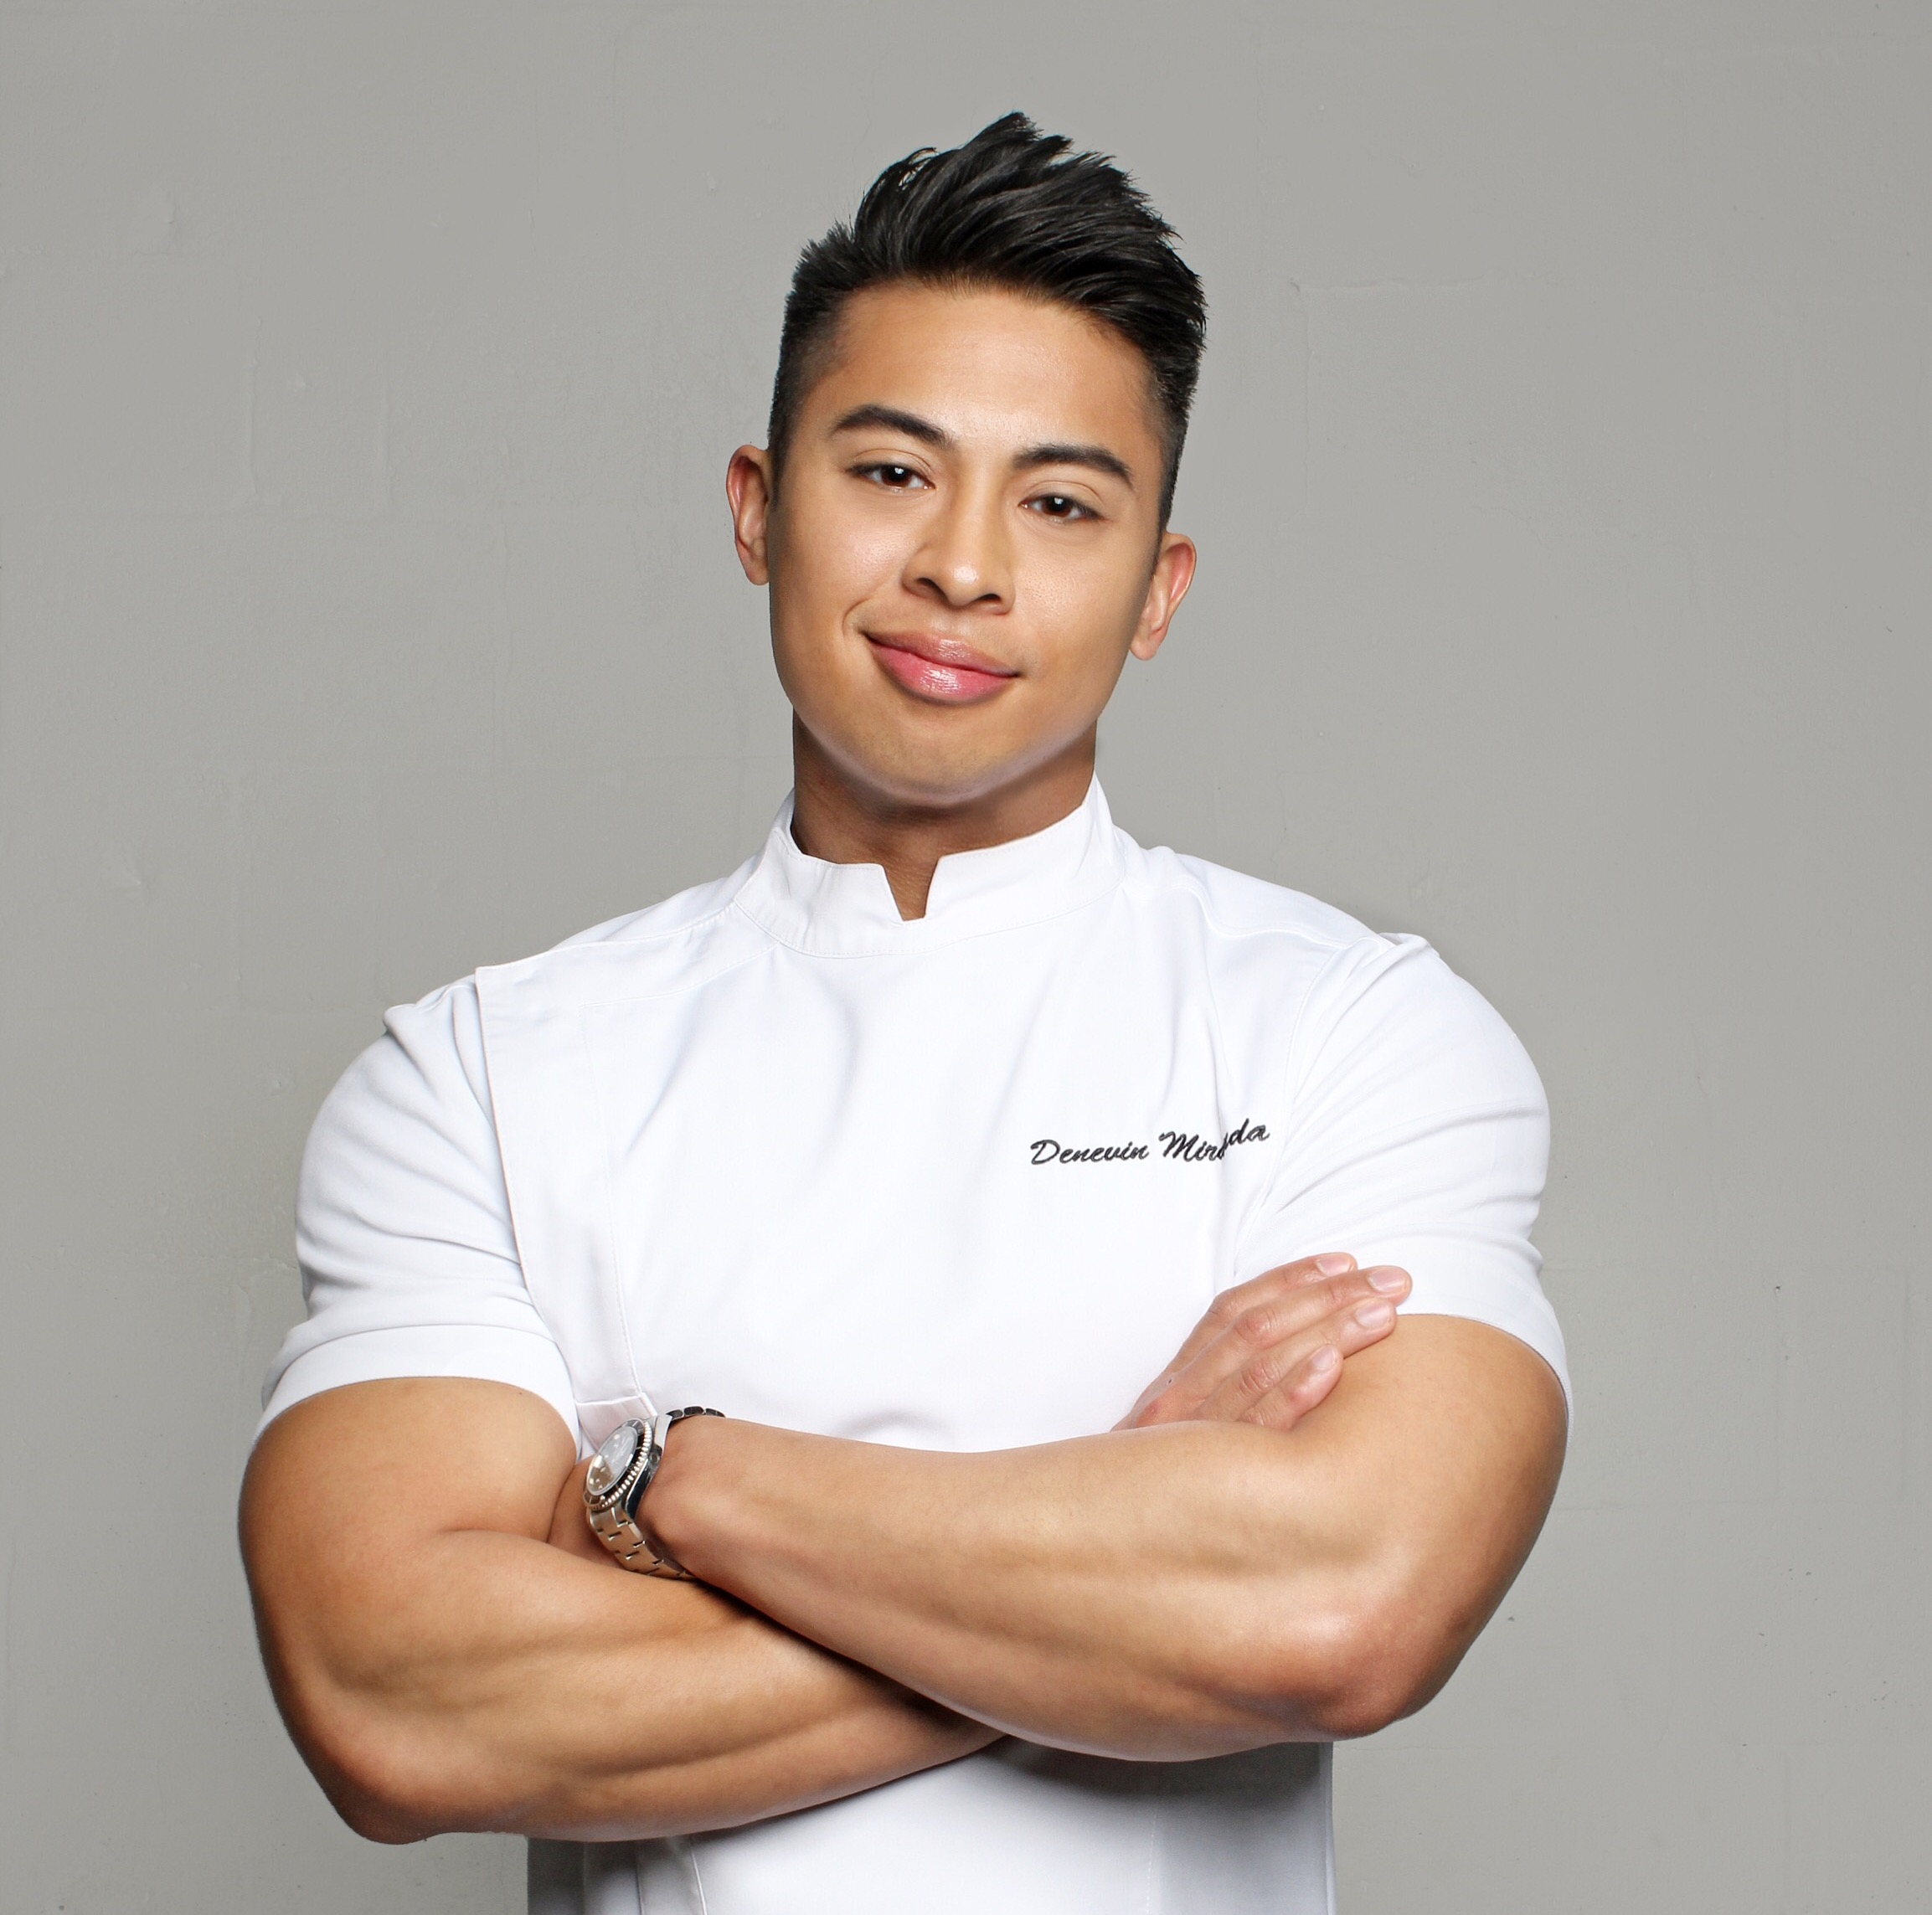 |  | DENEVIN MIRANDA
Profile  A hardworking, passionate, creative and results driven Professional Chef who is motivated to build a career in the culinary world. Extensive experience working in commercial kitchens, maintaining food quality, labor and equipment to the highest standards. Acquired many years working in Forbes 5-star, AAA 5-diamond and Leading Hotel of the World properties, cultivating an eye for detail, luxury and quality in both food preparation and food service. An appreciation for fine cuisine has garnered skills in both classical and modern cooking techniques giving the ability to design menus for the most discerning palates.  ACCOMPLISHMENTS  - Food Network’s Chopped Champion, 2021  - Miami’s Best New Restaurants, Katsuya Brickell, 2018  - Forbes 4 Star, The Setai Grill, 2014  Contact  PHONE:  305.343.8951  WEBSITE:  chefdenevin.com  EMAIL:  chefdenevin@gmail.com |  | WORK EXPerience  1 Hotel Brooklyn Bridge, New York, NY  Executive Chef of Outlets, 05/19 – Present  In charge of all restaurants and bars which includes The Osprey (3-meal restaurant), Neighbor’s Café, Harriet’s Lounge & Rooftop that contributes to the $20 million F&B operation. Responsible for inventory management and ordering; staff hiring, training and scheduling; food and labor cost control; creating and pricing food specials, as well as full menu development. Also, frequently involved in company growth and openings by providing assessments and task force support.  - Introduced global, “New American”, market-driven, sustainably focused, seasonal cuisine to The Osprey.  - Increased guest satisfaction scores from low 60s to over 90 and on-line review presence to over 4-stars across multiple platforms in 6-month period.  - Increased guest check average by 30% by raising quality and standards of food offerings and applying menu engineering.  - Created new, well received culinary concept for Harriet’s Lounge and Rooftop, a tapas style Japanese influenced menu that is better executed for the high-volume outlet which exceeds 1,000 covers daily during peak season.  - Revamped Neighbor’s Café menu to be more health-centric and customizable to entice local and residential clientele.  - Brought food purchasing practices to be more in line with brand standards by focusing on local, organic and biodynamic sources while maintaining budget and food costs.  - Implemented new catering and event menus that helped to increase revenue by 20% over previous year.  - Assisted in opening the London and Toronto properties and provided task force for South Beach and Princeville locations.  The Villa Casa Casuarina (formerly Versace Mansion), Miami Beach, FL  Chef Consultant, 01/19 – 04/19  Hired as a Chef Consultant to revamp menu; raise food quality and standards; improve hygiene and sanitation guidelines; implement more cost and control procedures.  - Introduced new menu in Gianni’s Restaurant focused on improving food quality and easier to execute relating to the limited kitchen space and increased volume of guests allowing them to extend hours of operation to include breakfast, lunch and dinner.  - Helped to open Sushi by Bou, an exclusive omakase sushi concept in the Versace Lounge adding an additional revenue center for the property.

WORK EXPerience (continued)

EDUCATION

Johnson & Wales University

North Miami, FL
Associate Degree, 2004 – 2007
- College of Culinary Arts
- Maintained 3.2 GPA
- Graduated with honors
- Participated in several extracurricular activities such as
the Campus Culinary Garden
and Culinary Competitions.

New York Department of Health
Food Safe Certified, 2020

Florida Food Safety Manager Training
Certificate of Completion, 2008
- Reduced food cost from over 50% to below 30% by controlling waste, revised portion sizes, recipe costing and set competitive food pricing from current and new vendors.
- Considerably improved sanitation scores by DOH inspection.
- Help hire, train and successfully transition new Executive Chef to take charge of the operation at the end of my consulting period.

SLS LUX Hotel & Residences, Miami, FL
Executive Chef in charge of Food and Beverage, 05/17 – 12/18
Oversaw pre-opening planning for this 86-room hotel and 450-unit residential building with 24-hour in-room dining, catering and events, rooftop pool restaurant, S Bar (an upscale lounge/bar), and Katsuya (280-seat high-end modern Japanese concept restaurant). Responsibilities included budgeting; profit and loss; kitchen design; purchasing; menu planning and development; building a leadership team and hiring of 130+ food and beverage FOH and BOH employees.
- Member of Executive Committee for sbe Miami and Brickell properties, helped create corporate SOPs and other high-level decision making.

sbe Hospitality and Entertainment Group, Southeast Region, USA
Corporate Executive Chef of Openings and Special Projects, 11/16 – 12/18
Most recently worked on the large scale opening of SLS Baha Mar in Nassau, Bahamas. A 300+ luxury hotel with 24-hour in-room dining, 7,000 sq. ft. banquet space, 2 nightclub venues and 9 restaurants all part of a sprawling billion-dollar beach resort and casino.
- Being part of the opening task force for these projects has imparted an indispensable and rewarding work experience.
- Led a team of chefs for research and development for new restaurant concepts and menus.

SKILLS

Carillon Wellness Resort (formerly Canyon Ranch), Miami Beach, FL
Chef de Cuisine, 09/15 – 10/16
Managed all culinary aspects of this $10 million annual luxury and health-oriented resort operating through multiple revenue centers.
- Helped the hotel rise in TripAdvisor rating from 59th position to number 1 by maintaining the highest standards in food quality and consistency.

The Setai Hotel, Miami Beach, FL
Chef de Cuisine, 04/08 – 09/15
Hired as a Chef de Partie for the acclaimed Forbes 5-star hotel and promoted several times with-in a 7-year tenure until achieving top toque as Chef de Cuisine. Duties included delegating responsibilities to the individual outlet Sous Chefs in the $12 million F&B operation; developing the schedule for the entire kitchen staff of 40+ cooks and stewards; creating relationships with vendors and purveyors; employee hiring, performance appraisals and disciplinary action.
- Remained a vital part in The Setai receiving the award for Forbes 5-star Hotel in 2015 and continued efforts in maintaining their status with-in Leading Hotels of the World.
INTERESTS

- Charitable Volunteer Work
- Physical and Functional Fitness
- Nutritional Science
- Amateur Gardening
- Outdoor Recreation
- Drawing and Painting
- TV and Movies
- Video Games

Mandarin Oriental, Brickell, FL
Chef de Partie, 02/05 – 10/06
Began as a culinary intern and later hired as a lead line cook for this Forbes 5-star, AAA 5-diamond rated luxury hotel.

